Principles of Data visualization

In the spring of 2021, nearly all of the American West was in a drought. Officials in Southern California declared a water emergency in April, citing unprecedented conditions. This probably didn’t come as news to residents of California and other Western states. Drought conditions like those in the West in 2021 are becoming increasingly common, yet communicating the extent of the problem remains difficult. How can this data be presented in a way that is both accurate and compelling enough to get people to take notice?

Data visualization designers Cédric Scherer and Georgios Karamanis took on this challenge in the fall of 2021 to create a graph of US drought conditions over the last two decades for the magazine Scientific American. They turned to the ggplot2 package to transform dry data (pardon the pun) from the National Drought Center into a visually arresting and impactful visualization.

This chapter explores why the data visualization that Scherer and Karamanis created is effective and introduces you to the grammar of graphics, a theory to make sense of graphs that underlies the ggplot2 package. You’ll then learn how to use ggplot2 by re-creating the drought graph step-by-step. In the process, I’ll highlight some key principles of high-quality data visualization that you can use to improve your own work.

The Drought Visualization

Other news organizations had relied on the same National Drought Center data in their stories, but Scherer and Karamanis visualized it so that it both grabs attention and communicates the scale of the phenomenon. Figure 2-1 shows a section of the final visualization (due to space constraints, I could include only four regions). The graph makes apparent the increase in drought conditions over the last two decades, especially in California and the Southwest.

[F02001.pdf]

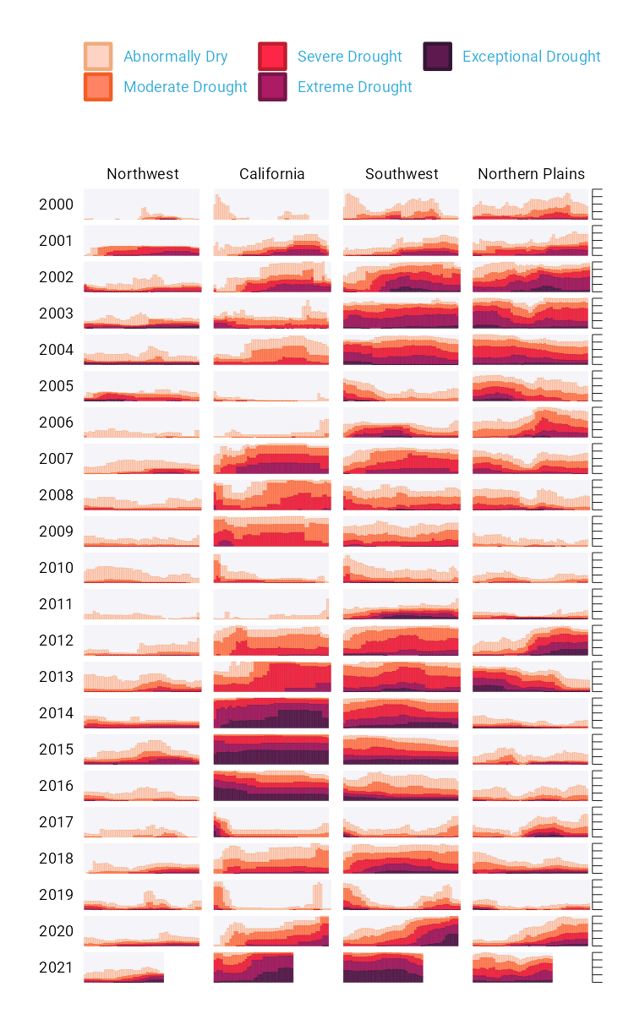

* + - * 1. A section of the final drought visualization, with a few tweaks made to fit this book

To understand why this visualization is effective, let’s break it down. At the broadest level, the data visualization is notable for its minimalist aesthetic. For example, there are no grid lines and few text labels, as well as minimal text along the axes. Scherer and Karamanis removed what statistician Edward Tufte, in his 1983 book The Visual Display of Quantitative Information, calls chartjunk. Tufte wrote that extraneous elements often hinder, rather than help, our understanding of charts (and researchers and data visualization designers have generally agreed).

Need proof that Scherer and Karamanis’s decluttered graph is better than the alternative? Figure 2-2 shows a version with a few tweaks to the code to include grid lines and text labels on axes.

[F02002.pdf]

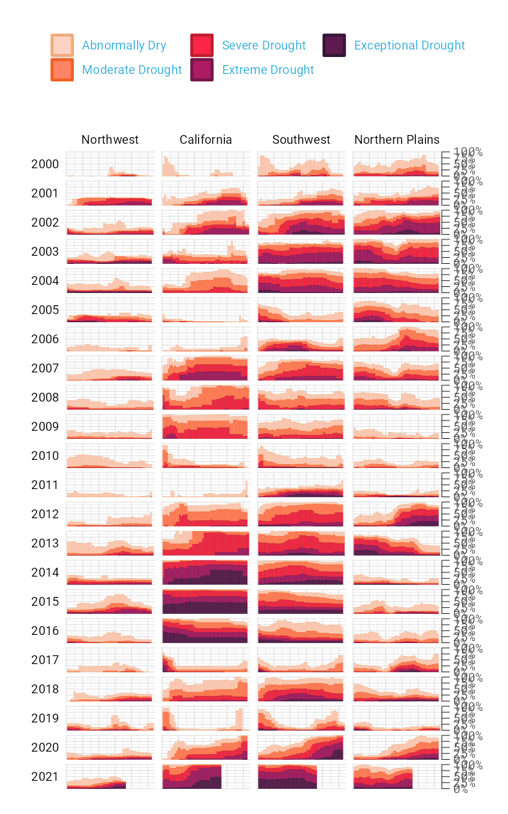

* + - * 1. The cluttered version of the drought visualization

It’s not just that this cluttered version looks worse; the clutter actively inhibits understanding. Rather than focusing on overall drought patterns (the point of the graph), our brains get stuck reading repetitive and unnecessary axis text.

One of the best ways to reduce clutter is to break a single chart into a set of component charts, as Scherer and Karamanis have done (this approach, known as faceting, will be discussed further in “Faceting the Plot” on page xx). Each rectangle represents one region in one year. Filtering the larger chart to show the Southwest region in 2003 and adding axis titles produces the graph shown in Figure 2-3, where the x-axis indicates the week and the y-axis indicates the percentage of that region at different drought levels.

[F02003.pdf]

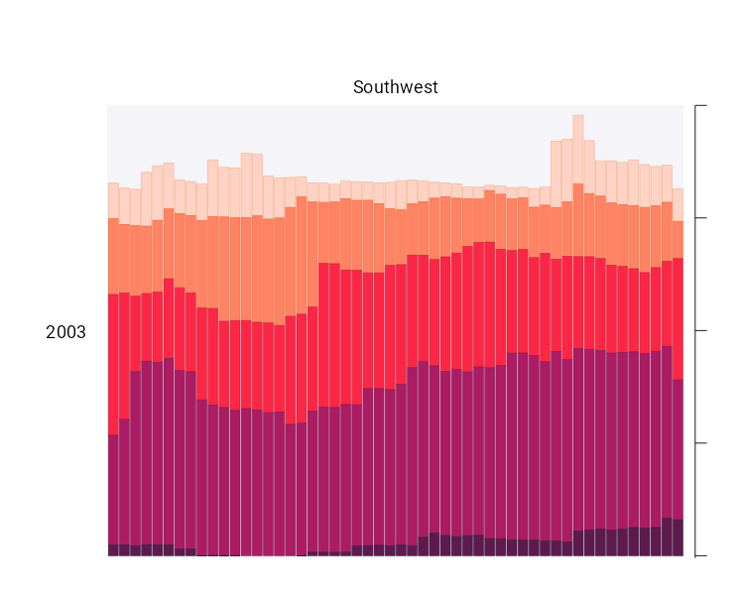

* + - * 1. A drought visualization for the Southwest in 2003

Zooming in on a single region in a single year also makes the color choices more obvious. The lightest orange bars show the percentage of the region that is abnormally dry, and the darkest purple bars show the percentage experiencing exceptional drought conditions. As you’ll see shortly, this range of colors was intentionally chosen to make differences in the drought levels visible to all readers.

Despite the graph’s complexity, the R code that Scherer and Karamanis wrote to produce it is relatively simple, due largely to a theory called the grammar of graphics.

The Grammar of Graphics

If you’ve used Excel to make graphs, you’re probably familiar with the menu shown in Figure 2-4. When working in Excel, you begin by selecting the type of graph you want to make. Need a bar chart? Click the bar chart icon. Need a line chart? Click the line chart icon.

[F02004.png]

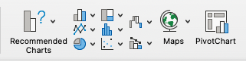

* + - * 1. The Excel chart menu

If you’ve only ever made charts in Excel, this first step may seem so obvious that you’ve never even given the data visualization process much thought, but in fact there are many ways to think about graphs. For example, rather than thinking of graph types as distinct, we can recognize and use their commonalities as the starting point for making them.

This approach to thinking about graphs comes from the late statistician Leland Wilkinson. For years, Wilkinson thought deeply about what data visualization is and how we can describe it. In 1999 he published a book called The Grammar of Graphics (Springer) that sought to develop a consistent way of describing all graphs. In it, Wilkinson argued that we should think of plots not as distinct types, à la Excel, but as following a grammar that we can use to describe any plot. Just as English grammar tells us that a noun is typically followed by a verb (which is why “he goes” works, while the opposite, “goes he,” does not), the grammar of graphics helps us understand why certain graph types “work.”

Thinking about data visualization through the lens of the grammar of graphics helps highlight, for example, that graphs typically have some data that is plotted on the x-axis and other data that is plotted on the y-axis. This is the case whether the graph is a bar chart or a line chart, as Figure 2-5 shows.

[F02005.pdf]

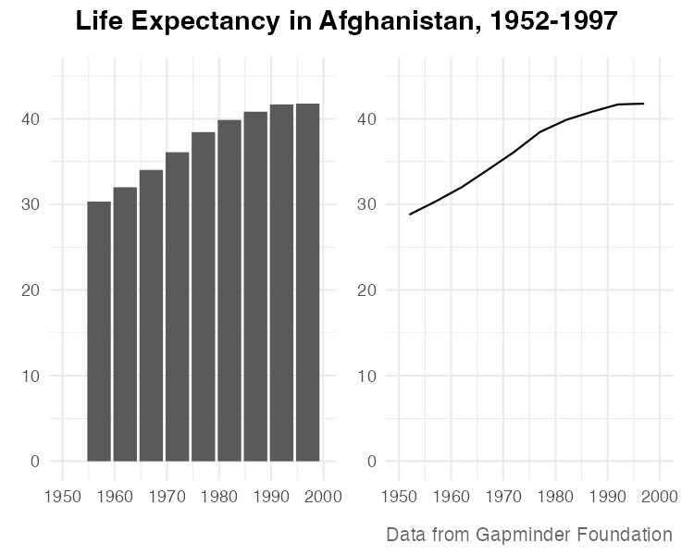

* + - * 1. A bar chart and a line chart showing identical data

While the graphs look different (and would, to the Excel user, be different types of graphs), Wilkinson’s grammar of graphics emphasizes their similarities. (Incidentally, Wilkinson’s feelings on graph-making tools like Excel became clear when he wrote that “most charting packages channel user requests into a rigid array of chart types.”)

When Wilkinson wrote his book, no data visualization tool could implement his grammar of graphics. This would change in 2010, when Hadley Wickham announced the ggplot2 package for R in an article titled “A Layered Grammar of Graphics,” published in the Journal of Computational and Graphical Statistics. By providing the tools to implement Wilkinson’s ideas, ggplot2 would come to revolutionize the world of data visualization.

Working with ggplot2

The ggplot2 R package (which I, like nearly everyone in the data visualization world, will refer to simply as ggplot) relies on the idea of plots having multiple layers. This section will walk you through some of the most important ones. You’ll begin by selecting variables to map to aesthetic properties. Then you’ll choose a geometric object to use to represent your data. Next, you’ll change the aesthetic properties of your chart (its color scheme, for example) using a scale_ function. Finally, you’ll use a theme_ function to set the overall look and feel of your plot.

Mapping Data to Aesthetic Properties

To create a graph with ggplot, you begin by mapping data to aesthetic properties. All this really means is that you use elements like the x- or y-axis, color, and size (the so-called aesthetic properties) to represent variables. You’ll use the data on life expectancy in Afghanistan, introduced in Figure 2-5, to generate a plot. To access this data, enter the following code:

library(tidyverse)

gapminder_10_rows <- read_csv("https://data.rwithoutstatistics.com/data/gapminder_10_rows.csv")

This code first loads the tidyverse package, introduced in Chapter 1, and then uses the read_csv() function to access data from the book’s website and assign it to the gapminder_10_rows object.

The resulting gapminder_10_rows tibble looks like this:

#> # A tibble: 10 × 6

#> country continent year lifeExp pop gdpPercap

#> <fct> <fct> <int> <dbl> <int> <dbl>

#> 1 Afghanistan Asia 1952 28.8 8425333 779.

#> 2 Afghanistan Asia 1957 30.3 9240934 821.

#> 3 Afghanistan Asia 1962 32.0 10267083 853.

#> 4 Afghanistan Asia 1967 34.0 11537966 836.

#> 5 Afghanistan Asia 1972 36.1 13079460 740.

#> 6 Afghanistan Asia 1977 38.4 14880372 786.

#> 7 Afghanistan Asia 1982 39.9 12881816 978.

#> 8 Afghanistan Asia 1987 40.8 13867957 852.

#> 9 Afghanistan Asia 1992 41.7 16317921 649.

#> 10 Afghanistan Asia 1997 41.8 22227415 635.

This output is a shortened version of the full gapminder data frame, which includes over 1,700 rows of data.

Before making a chart with ggplot, you need to decide which variable to put on the x-axis and which to put on the y-axis. For data showing change over time, it’s common to put the date (in this case, year) on the x-axis and the changing value (in this case, lifeExp) on the y-axis. To do so, define the ggplot() function as follows:

ggplot(

data = gapminder_10_rows,

mapping = aes(

x = year,

y = lifeExp

)

)

This function contains numerous arguments. Each argument goes on its own line, for the sake of readability, separated by commas. The data argument tells R to use the data frame gapminder_10_rows, and the mapping argument maps year to the x-axis and lifeExp to the y-axis.

Running this code produces the chart in Figure 2-6, which doesn’t look like much yet.

[F02006.pdf]

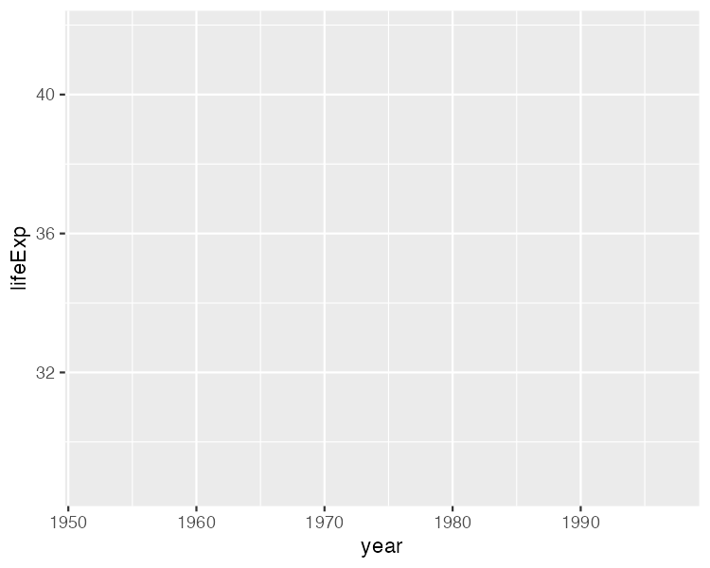

* + - * 1. A blank chart that maps year values to the x-axis and life expectancy values to the y-axis

Notice that the x-axis corresponds to year and the y-axis corresponds to lifeExp, and the values on both axes match the scope of the data. In the gapminder_10_rows data frame, the first year is 1952 and the last year is 1997. The range of the x-axis has been created with this data in mind. Likewise, the values for lifeExp, which go from about 28 to about 42, will fit nicely on the y-axis.

Choosing the Geometric Objects

Axes are nice, but the graph is missing any type of visual representation of the data. To get this, you need to add the next ggplot layer: geoms. Short for geometric objects, geoms are functions that provide different ways of representing data. For example, to add points to the graph, you use geom_point():

ggplot(

data = gapminder_10_rows,

mapping = aes(

x = year,

y = lifeExp

)

) +

geom_point()

Now the graph shows that people in 1952 had a life expectancy of about 28 and that this value rose every year in the data set (see Figure 2-7).

[F02007.pdf]

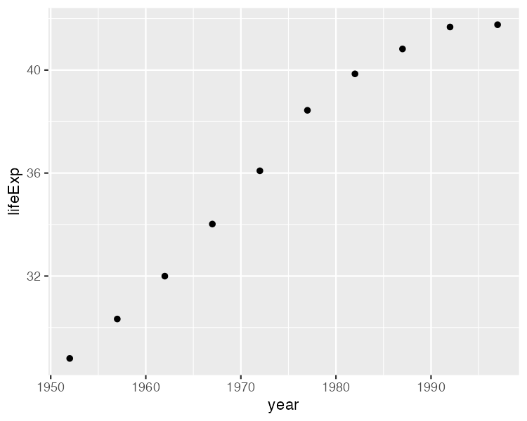

* + - * 1. The life expectancy chart with points added

Say you change your mind and want to make a line chart instead. All you have to do is replace geom_point() with geom_line() like so:

ggplot(

data = gapminder_10_rows,

mapping = aes(

x = year,

y = lifeExp

)

) +

geom_line()

Figure 2-8 shows the result.

[F02008.pdf]

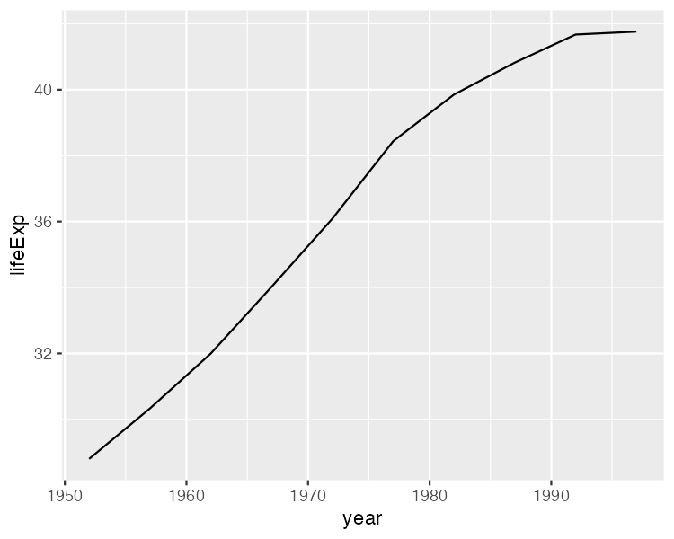

* + - * 1. The same data as a line chart

To really get fancy, you could add both geom_point() and geom_line() as follows:

ggplot(

data = gapminder_10_rows,

mapping = aes(

x = year,

y = lifeExp

)

) +

geom_point() +

geom_line()

This code generates a line chart with points, as shown in Figure 2-9.

[F02009.pdf]

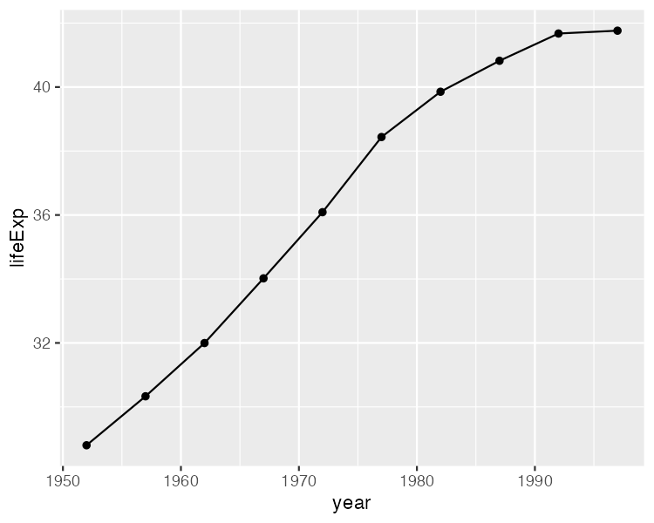

* + - * 1. The same data with both points and a line

You can swap in geom_col() to create a bar chart:

ggplot(

data = gapminder_10_rows,

mapping = aes(

x = year,

y = lifeExp

)

) +

geom_col()

Notice in Figure 2-10 that the y-axis range has been automatically updated, going from 0 to 40 to account for the different geom.

[F02010.pdf]

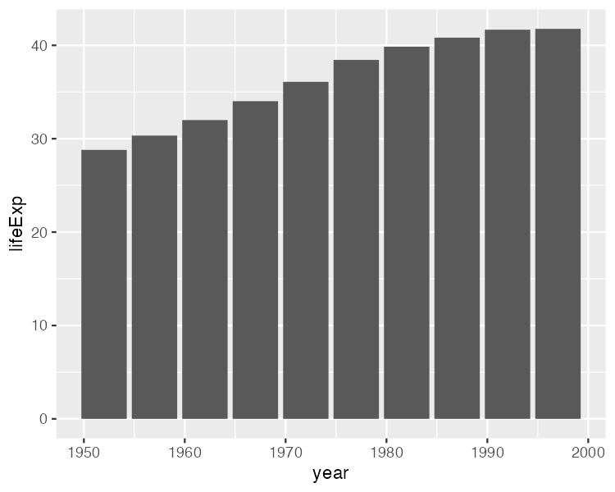

* + - * 1. The life expectancy data as a bar chart

As you can see, the difference between a line chart and a bar chart isn’t as great as the Excel chart-type picker might have you believe. Both can have the same underlying properties (namely, years on the x-axis and life expectancies on the y-axis). They simply use different geometric objects to visually represent the data.

Many geoms are built into ggplot. In addition to geom_bar(), geom_point(), and geom_line(), the geoms geom_histogram(), geom_boxplot(), and geom_area() are among the most commonly used. To see all geoms, visit the ggplot documentation website at https://ggplot2.tidyverse.org/reference/index.html#geoms.

Altering Aesthetic Properties

Before we return to the drought data visualization, let’s look at a few additional layers you can use to alter the bar chart. Say you want to change the color of the bars. In the grammar of graphics approach to chart-making, this means mapping some variable to the aesthetic property of fill. (For a bar chart, the aesthetic property of color would change only the outline of each bar.) In the same way that you mapped year to the x-axis and lifeExp to the y-axis, you can map fill to a variable, such as year:

ggplot(

data = gapminder_10_rows,

mapping = aes(

x = year,

y = lifeExp,

fill = year

)

) +

geom_col()

Figure 2-11 shows the result. Now, the fill is darker for earlier years, and lighter for later years (as also indicated by the legend, added to the right of the plot).

[F02011.pdf]

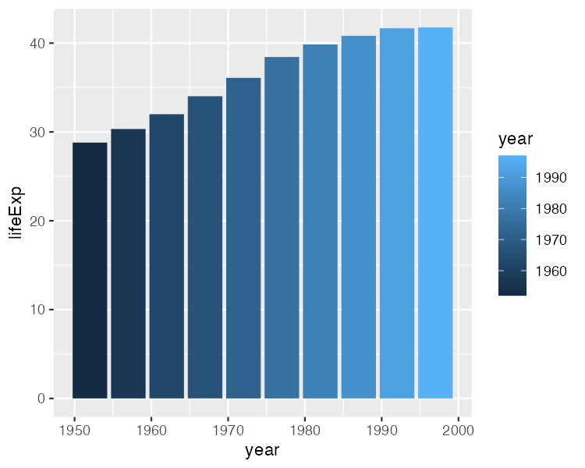

* + - * 1. The same chart, now with added colors

To change the fill colors, use a new scale layer with the scale_fill_viridis_c() function (the c at the end of the function name refers to the fact that the data is continuous, meaning it can take any numeric value):

ggplot(

data = gapminder_10_rows,

mapping = aes(

x = year,

y = lifeExp,

fill = year

)

) +

geom_col() +

scale_fill_viridis_c()

This function changes the default palette to one that is colorblind-friendly and prints well in grayscale. The scale_fill_viridis_c() function is just one of many that start with scale_ and can alter the fill scale. Chapter 11 of ggplot2: Elegant Graphics for Data Analysis, 3rd Edition (Springer, 2023), discusses various color and fill scales. You can read it online at https://ggplot2-book.org/scales-colour.html.

Setting a Theme

The final layer we’ll look at is the theme layer, which allows you to change the overall look and feel of your plots (including their background and grid lines). As with the scale_ functions, a number of functions also start with theme_. Add theme_minimal() as follows:

ggplot(

data = gapminder_10_rows,

mapping = aes(

x = year,

y = lifeExp,

fill = year

)

) +

geom_col() +

scale_fill_viridis_c() +

theme_minimal()

This theme starts to declutter the plot, as you can see in Figure 2-12.

[F02012.pdf]

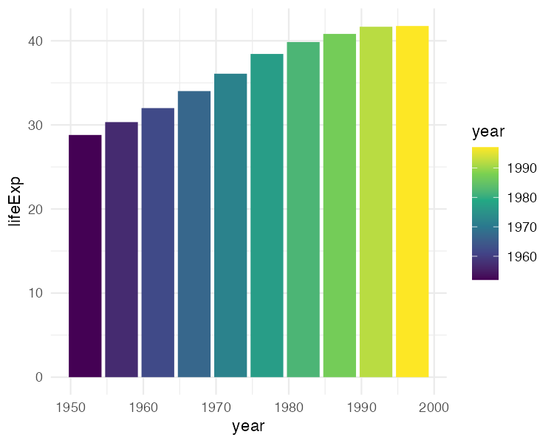

* + - * 1. The same chart with theme_minimal() added

By now, you should see why Hadley Wickham described the ggplot2 package as using a layered grammar of graphics. It implements Wilkinson’s theory by creating multiple layers: first, variables to map to aesthetic properties; second, geoms to represent the data; then, the scale_ function to adjust aesthetic properties; and finally, the theme_ function to set the plot’s overall look and feel.

You could still improve this plot in many ways, but instead let’s return to the drought data visualization by Scherer and Karamanis. By walking through their code, you’ll learn about making high-quality data visualization with ggplot and R.

Re-creating the Drought Visualization

The drought visualization code relies on a combination of ggplot fundamentals and some lesser-known tweaks that make it really shine. To understand how Scherer and Karamanis made their data visualization, we’ll start with a simplified version of their code, then build it up layer by layer, adding elements as we go.

First, you’ll import the data. Because it’s in JavaScript Object Notation (JSON) format, Scherer and Karamanis use the import() function from the rio package, which simplifies the process of importing JSON data:

library(rio)

dm_perc_cat_hubs_raw <- import("https://data.rwithoutstatistics.com/

dm_export_20000101_20210909_perc_cat_hubs.json"))

JSON is a common format for data used in web applications, though it’s far less common in R, where it can be complicated to work with. Luckily, the rio package simplifies its import.

Plotting One Region and Year

Scherer and Karamanis’s final plot consists of many years and regions. To see how they created it, we’ll start by looking at just the Southwest region in 2003.

First, you need to create a data frame. You’ll use the filter() function twice: the first time to keep only data for the Southwest region, and the second time to keep only data from 2003. In both cases, you use the following syntax:

filter(variable_name == value)

This tells R to keep only observations where variable_name is equal to some value. The code starts with the dm_perc_cat_hubs_raw data frame before filtering it and then saving it as a new object called southwest_2003:

southwest_2003 <- dm_perc_cat_hubs %>%

filter(hub == "Southwest") %>%

filter(year == 2003)

To take a look at this object and see the variables you have to work with, enter southwest_2003 in the console, which should return this output:

#> # A tibble: 255 × 7

#> date hub category percentage year week max_week

#> <date> <fct> <fct> <dbl> <dbl> <dbl> <dbl>

#> 1 2003-12-30 Sout... D0 0.0718 2003 52 52

#> 2 2003-12-30 Sout... D1 0.0828 2003 52 52

#> 3 2003-12-30 Sout... D2 0.2693 2003 52 52

#> 4 2003-12-30 Sout... D3 0.3108 2003 52 52

#> 5 2003-12-30 Sout... D4 0.0796 2003 52 52

#> 6 2003-12-23 Sout... D0 0.0823 2003 51 52

#> 7 2003-12-23 Sout... D1 0.1312 2003 51 52

#> 8 2003-12-23 Sout... D2 0.1886 2003 51 52

#> 9 2003-12-23 Sout... D3 0.3822 2003 51 52

#> 10 2003-12-23 Sout... D4 0.0828 2003 51 52

#> # 245 more rows

The date variable represents the start date of the week in which the observation took place. The hub variable is the region, and category is the level of drought: a value of D0 indicates the lowest level of drought, while D5 indicates the highest level. The percentage variable is the percentage of that region in that drought category, ranging from 0 to 1. The year and week variables are the observation year and week number (beginning with week 1). The max_week variable is the maximum number of weeks in a given year.

Now you can use this southwest_2003 object for your plot:

ggplot(

data = southwest_2003,

aes(

x = week,

y = percentage,

fill = category

)

) +

geom_col()

The ggplot() function tells R to put week on the x-axis and percentage on the y-axis, as well as to use the category variable for the fill color. The geom_col() function creates a bar chart in which each bar’s fill color represents the percentage of the region at each drought level for that particular week, as shown in Figure 2-13.

[F02013.pdf]

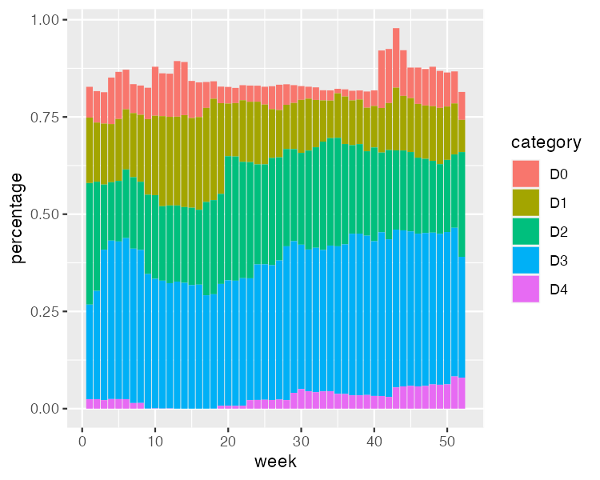

* + - * 1. One year (2003) and region (Southwest) of the drought visualization

The colors, which include bright pinks, blues, greens, and reds, don’t match the final version of the plot, but you can start to see the outlines of Scherer and Karamanis’s data visualization.

Changing Aesthetic Properties

Scherer and Karamanis next selected different fill colors for their bars. To do so, they used the scale_fill_viridis_d() function. The d here means that the data to which the fill scale is being applied has discrete categories (D0, D1, D2, D3, D4, and D5):

ggplot(

data = southwest_2003,

aes(

x = week,

y = percentage,

fill = category

)

) +

geom_col() +

scale_fill_viridis_d(

option = "rocket",

direction = -1

)

They used the argument option = "rocket" to select the rocket palette, whose colors range from cream to nearly black. You could use several other palettes within the scale_fill_viridis_d() function; see them at https://sjmgarnier.github.io/viridisLite/reference/viridis.html.

Then they used the direction = -1 argument to reverse the order of fill colors so that darker colors mean higher drought conditions.

Scherer and Karamanis also tweaked the appearance of the x- and y- axes:

ggplot(

data = southwest_2003,

aes(

x = week,

y = percentage,

fill = category

)

) +

geom_col() +

scale_fill_viridis_d(

option = "rocket",

direction = -1

) +

scale_x_continuous(

name = NULL,

guide = "none"

) +

scale_y_continuous(

name = NULL,

labels = NULL,

position = "right"

)

On the x-axis, they removed both the axis title (“week”) using name = NULL and the axis labels (the weeks numbered 0 to 50) with guide = "none". On the y-axis, they removed the title and text showing percentages using labels = NULL, which functionally does the same thing as guide = "none". They also moved the axis lines themselves to the right side using position = "right". These axis lines are apparent only as tick marks at this point but will become more visible later. Figure 2-14 shows the result of these tweaks.

[F02014.pdf]

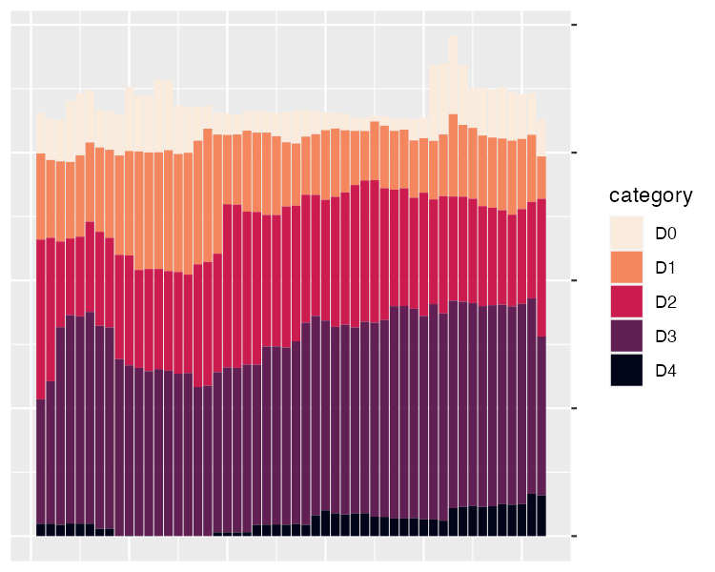

* + - * 1. The 2003 drought data for the Southwest with adjustments to the x- and y-axes

Up to this point, we’ve focused on one of the single plots that make up the larger data visualization. But the final product that Scherer and Karamanis made is actually 176 plots visualizing 22 years and 8 regions. Let’s discuss the ggplot feature they used to create all of these plots.

Faceting the Plot

One of ggplot’s most useful capabilities is faceting (or, as it’s more commonly known in the data visualization world, small multiples). Faceting uses a variable to break down a single plot into multiple plots. For example, think of a line chart showing life expectancy by country over time; instead of multiple lines on one plot, faceting would create multiple plots with one line per plot. To specify which variable to put in the rows and which to put in the columns of your faceted plot, you use the facet_grid() function, as Scherer and Karamanis did in their code:

dm_perc_cat_hubs %>%

filter(hub %in% c(

"Northwest",

"California",

"Southwest",

"Northern Plains"

)) %>%

ggplot(aes(

x = week,

y = percentage,

fill = category

)) +

geom_col() +

scale_fill_viridis_d(

option = "rocket",

direction = -1

) +

scale_x_continuous(

name = NULL,

guide = "none"

) +

scale_y_continuous(

name = NULL,

labels = NULL,

position = "right"

) +

facet_grid(

rows = vars(year),

cols = vars(hub),

switch = "y"

)

Scherer and Karamanis put year in rows and hub (region) in columns. The switch = "y" argument moves the year label from the right side (where it appears by default) to the left. With this code in place, you can see the final plot coming together in Figure 2-15.

[F02015.pdf]

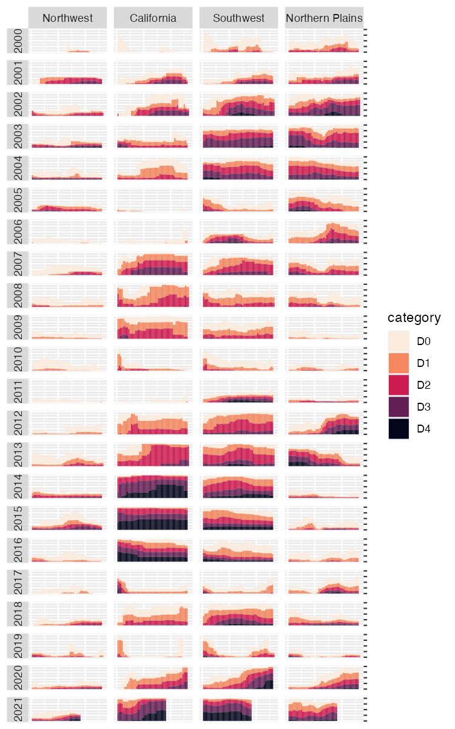

* + - * 1. The faceted version of the drought visualization

Incredibly, the broad outlines of the plot took just 10 lines of code to create. The rest of the code falls into the category of small polishes. That’s not to minimize how important small polishes are (very) or the time it takes to create them (lots). It does show, however, that a little bit of ggplot goes a long way.

Adding Final Polishes

Now let’s look at a few of the small polishes that Scherer and Karamanis made. The first is to apply a theme. They used theme_light(), which removes the default gray background and changes the font to Roboto using the base_family argument.

The theme_light() function is what’s known as a complete theme, one that changes the overall look and feel of a plot. The ggplot package has multiple complete themes that you can use (they’re listed at https://ggplot2.tidyverse.org/reference/index.html#themes). Individuals and organizations also make their own themes, as you’ll do in Chapter 3. For a discussion of which themes you might consider using, see my blog post at https://rfortherestofus.com/2019/08/themes-to-improve-your-ggplot-figures.

Scherer and Karamanis didn’t stop by simply applying theme_light(). They also used the theme() function to make additional tweaks to the plot’s design:

dm_perc_cat_hubs %>%

filter(hub %in% c(

"Northwest",

"California",

"Southwest",

"Northern Plains"

)) %>%

ggplot(aes(

x = week,

y = percentage,

fill = category

)) +

geom_rect(

aes(

xmin = .5,

xmax = max_week + .5,

ymin = -0.005,

ymax = 1

),

fill = "#f4f4f9",

color = NA,

size = 0.4

) +

geom_col() +

scale_fill_viridis_d(

option = "rocket",

direction = -1

) +

scale_x_continuous(

name = NULL,

guide = "none"

) +

scale_y_continuous(

name = NULL,

labels = NULL,

position = "right"

) +

facet_grid(

rows = vars(year),

cols = vars(hub),

switch = "y"

) +

theme_light(base_family = "Roboto") +

theme(

axis.title = element_text(

size = 14,

color = "black"

),

axis.text = element_text(

family = "Roboto Mono",

size = 11

),

1 axis.line.x = element_blank(),

axis.line.y = element_line(

color = "black",

size = .2

),

axis.ticks.y = element_line(

color = "black",

size = .2

),

axis.ticks.length.y = unit(2, "mm"),

2 legend.position = "top",

legend.title = element_text(

color = "#2DAADA",

face = "bold"

),

legend.text = element_text(color = "#2DAADA"),

strip.text.x = element_text(

hjust = .5,

face = "plain",

color = "black",

margin = margin(t = 20, b = 5)

),

strip.text.y.left = element_text(

3 angle = 0,

vjust = .5,

face = "plain",

color = "black"

),

strip.background = element_rect(

fill = "transparent",

color = "transparent"

),

panel.grid.minor = 4 element_blank(),

panel.grid.major = element_blank(),

panel.spacing.x = unit(0.3, "lines"),

panel.spacing.y = unit(0.25, "lines"),

5 panel.background = element_rect(

fill = "transparent",

color = "transparent"

),

panel.border = element_rect(

color = "transparent",

size = 0

),

plot.background = element_rect(

fill = "transparent",

color = "transparent",

size = .4

),

plot.margin = margin(rep(18, 4))

)

)

The code in the theme() function does many different things, but let’s look at a few of the most important. First, it moves the legend from the right side (the default) to the top of the plot 2. Then, the angle = 0 argument rotates the year text in the columns from vertical to horizontal 3. Without this argument, the years would be much less legible.

The theme() function also makes the distinctive axis lines and ticks that appear on the right side of the final plot 1. Calling element_blank() removes all grid lines 4. Finally, this code removes the borders and gives each individual plot a transparent background 5.

You might be thinking, Wait. Didn’t the individual plots have a gray background behind them? Yes, dear reader, they did. Scherer and Karamanis made these with a separate geom, geom_rect():

geom_rect(

aes(

xmin = .5,

xmax = max_week + .5,

ymin = -0.005,

ymax = 1

),

fill = "#f4f4f9",

color = NA,

size = 0.4

)

They also set some additional aesthetic properties specific to this geom—xmin, xmax, ymin, and ymax—which determine the boundaries of the rectangle it produces. The result is a gray background behind each small multiple, as shown in Figure 2-16.

[F02016.pdf]

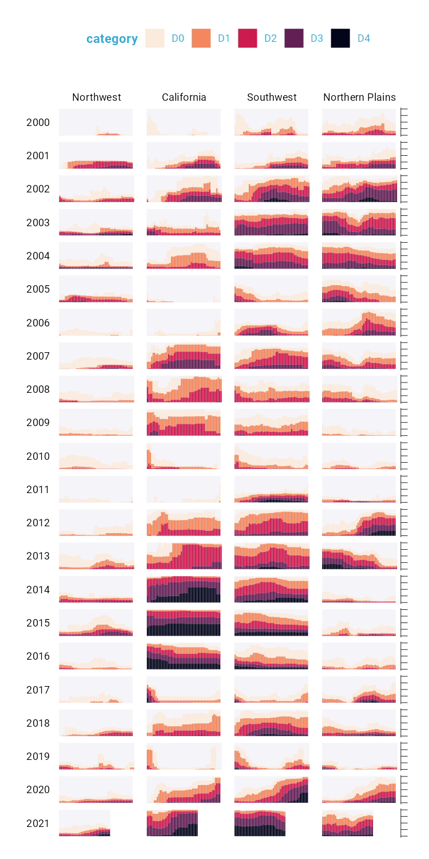

* + - * 1. The faceted version of the drought visualization with a gray background behind each small multiple

Finally, Scherer and Karamanis made some tweaks to the legend. Previously you saw a simplified version of the scale_fill_viridis_d() function. Here’s a more complete version:

scale_fill_viridis_d(

option = "rocket",

direction = -1,

name = "Category:",

labels = c(

"Abnormally Dry",

"Moderate Drought",

"Severe Drought",

"Extreme Drought",

"Exceptional Drought"

)

)

The name argument sets the legend title, and the labels argument specifies the labels that show up in the legend. Figure 2-17 shows the result of these changes.

[F02017.pdf]



* + - * 1. The drought visualization with changes to the legend text

Rather than D0, D1, D2, D3, and D4, the legend text now reads Abnormally Dry, Moderate Drought, Severe Drought, Extreme Drought, and Exceptional Drought—much more user-friendly categories.

The Complete Visualization Code

While I’ve shown you a nearly complete version of the code that Scherer and Karamanis wrote, I made some small changes to make it easier to understand. If you’re curious, the full code is here:

ggplot(dm_perc_cat_hubs, aes(week, percentage)) +

geom_rect(

aes(

xmin = .5,

xmax = max_week + .5,

ymin = -0.005,

ymax = 1

),

fill = "#f4f4f9",

color = NA,

size = 0.4,

show.legend = FALSE

) +

geom_col(

aes(

fill = category,

fill = after_scale(addmix(

darken(

fill,

.05,

space = "HLS"

),

"#d8005a",

.15

)),

color = after_scale(darken(

fill,

.2,

space = "HLS"

))

),

width = .9,

size = 0.12

) +

facet_grid(

rows = vars(year),

cols = vars(hub),

switch = "y"

) +

coord_cartesian(clip = "off") +

scale_x_continuous(

expand = c(.02, .02),

guide = "none",

name = NULL

) +

scale_y_continuous(

expand = c(0, 0),

position = "right",

labels = NULL,

name = NULL

) +

scale_fill_viridis_d(

option = "rocket",

name = "Category:",

direction = -1,

begin = .17,

end = .97,

labels = c(

"Abnormally Dry",

"Moderate Drought",

"Severe Drought",

"Extreme Drought",

"Exceptional Drought"

)

) +

guides(fill = guide_legend(

nrow = 2,

override.aes = list(size = 1)

)) +

theme_light(

base_size = 18,

base_family = "Roboto"

) +

theme(

axis.title = element_text(

size = 14,

color = "black"

),

axis.text = element_text(

family = "Roboto Mono",

size = 11

),

axis.line.x = element_blank(),

axis.line.y = element_line(

color = "black",

size = .2

),

axis.ticks.y = element_line(

color = "black",

size = .2

),

axis.ticks.length.y = unit(2, "mm"),

legend.position = "top",

legend.title = element_text(

color = "#2DAADA",

size = 18,

face = "bold"

),

legend.text = element_text(

color = "#2DAADA",

size = 16

),

strip.text.x = element_text(

size = 16,

hjust = .5,

face = "plain",

color = "black",

margin = margin(t = 20, b = 5)

),

strip.text.y.left = element_text(

size = 18,

angle = 0,

vjust = .5,

face = "plain",

color = "black"

),

strip.background = element_rect(

fill = "transparent",

color = "transparent"

),

panel.grid.minor = element_blank(),

panel.grid.major = element_blank(),

panel.spacing.x = unit(0.3, "lines"),

panel.spacing.y = unit(0.25, "lines"),

panel.background = element_rect(

fill = "transparent",

color = "transparent"

),

panel.border = element_rect(

color = "transparent",

size = 0

),

plot.background = element_rect(

fill = "transparent",

color = "transparent",

size = .4

),

plot.margin = margin(rep(18, 4))

)

There are a few additional tweaks to color and spacing, but most of the code reflects what you’ve seen so far.

Conclusion

You may be thinking that ggplot is the solution to all of your data visualization problems. And yes, you have a new hammer, but not everything is a nail. If you look at the version of the data visualization that appeared in Scientific American in November 2021, you’ll see that some of its annotations aren’t visible in our re-creation. That’s because they were added in post-production. While you could have found ways to create them in ggplot, it’s often not the best use of your time. Get yourself 90 percent of the way there with ggplot and then use Illustrator, Figma, or a similar tool to finish your work.

Even so, ggplot is a very powerful hammer, used to make plots that you’ve seen in the New York Times, FiveThirtyEight, the BBC, and other well-known news outlets. Although it’s not the only tool that can generate high-quality data visualizations, it makes the process straightforward. The graph by Scherer and Karamanis shows this in several ways:

It strips away extraneous elements, such as grid lines, to keep the focus on the data itself.

Complete themes such as theme_light() and the theme() function allowed Scherer and Karamanis to create a decluttered visualization that communicates effectively.

It uses well-chosen colors.

The scale_fill_viridis_d() function allowed them to create a color scheme that demonstrates differences between groups, is colorblind-friendly, and shows up well when printed in grayscale.

It uses faceting to break down data from two decades and eight regions into a set of graphs that come together to create a single plot.

With a single call to the facet_grid() function, Scherer and Karamanis created over 100 small multiples that the tool automatically combined into a single plot.

Learning to create data visualizations in ggplot involves a significant time investment. But the long-term payoff is even greater. Once you learn how ggplot works, you can look at others’ code and learn how to improve your own. By contrast, when you make a data visualization in Excel, the series of point-and-click steps disappears into the ether. To re-create a visualization you made last week, you’ll need to remember the exact steps you used, and to make someone else’s data visualization, you’ll need them to write up their process for you.

Because code-based data visualization tools allow you to keep a record of the steps you made, you don’t have to be the most talented designer to make high-quality data visualizations with ggplot. You can study others’ code, adapt it to your own needs, and create your own data visualization that not only is beautiful but also communicates effectively.

Further Resources

Will Chase, “The Glamour of Graphics,” online course, accessed November 6, 2023, https://rfortherestofus.com/courses/glamour/.

Kieran Healy, Data Visualization: A Practical Introduction (Princeton, NJ: Princeton University Press, 2018), https://socviz.co/.

Cédric Scherer, Graphic Design with ggplot2 by Cédric Scherer (Boca Raton, FL: CRC Press, forthcoming).

Hadley Wickham, Danielle Navarro, and Thomas Lin Pedersen, ggplot2: Elegant Graphics for Data Analysis, 3rd ed. (New York: Springer, forthcoming), https://ggplot2-book.org/.

Claus Wilke, Fundamentals of Data Visualization (Sebastopol, CA: O’Reilly Media, 2019), https://clauswilke.com/dataviz/.